**SUMMER TRAINING PROJECT REPORT**

TOWARDS THE

PARTIAL FULFILLMENT OF

**BACHELOR OF BUSINESS ADMINISTRATION**



**COMPUTER APPLICATIONS PROJECT**

**ON**

**“LUXURY CARS”**

**Batch 2013-16**

**PROJECT GUIDE: - SUBMITTED BY:-**

**Mrs. Natasha Maniktahla Kartik Gupta**

**Mrs. Ruchika Bajaj BBA(G)/5Sem/2ndShift . 00124001713**



**TRINITY INSTITUTE OF PROFESSIONAL STUDIES**

Affiliated To Guru Gobind Singh Indraprastha University

**Certificate**

**TO WHOM SO EVER IT MAY CONCERN**

This is to certify that the project work **“LUXURY CARS”** made by **KARTIK GUPTA**, **BBA (GEN), ENROLLMENT NO. 00124001713** is an authentic work carried out by his guidance and supervision of **Mrs. Natasha Maniktahla** and **Mrs. Ruchika Bajaj.**

The project report submitted has been found satisfactory for the partial fulfillment of the degree of Bachelor of Business Administration

**(Project Supervisor)**

**Signature**

**Mrs. Natasha Maniktahla**

**Mrs. Ruchika Bajaj**

**Acknowledgement**

It is in particular that I am acknowledging my sincere feeling towards my mentors who graciously gave me their time and expertise.

They have provided me with the valuable guidance, sustained efforts and friendly approach. It would have been difficult to achieve the result in such a short span of time without their help.

I deem it my duty to record my gratitude towards the **Project Supervisor, Mrs. Natasha Maniktahla** and **Mrs. Ruchika Bajaj** who devoted her precious time to interact, guide and gave me the right approach to accomplish the task and also helped me to enhance my knowledge and understanding of the project.

**Signature:**

**Name: - Kartik Gupta**

**Course: - BBA (G)**

**Sem/Year/Shift: - 5th Sem/3nd Year/2nd Shift**

**Enrolment no.: - 00124001713**

**Declaration**

I hereby declare that the following documented project report titled “**LUXURY CARS**” is an original and authentic work done by me for the partial fulfillment of Bachelors of Business Administration degree program.

I hereby certify that all the Endeavour put in the fulfillment of the task are genuine and original to the best of my knowledge and I have not submitted it earlier elsewhere.

**Signature:**

**Name: - Kartik Gupta**

**Course: - BBA (G)**

**Sem/Year/Shift: - 5th Sem/3nd Year/2nd Shift**

**Enrolment no.: - 00124001713**

**TABLE OF CONTENTS**

|  |  |  |
| --- | --- | --- |
| **S.NO.** | **Particulars** | **Pg.No.** |
| **1.** | **Introduction** | **1-2** |
| **2.** | **Existing System** | **3-4** |
| **3.** | **Proposed System** | **5-7** |
| **4.** | **System Requirement** | **8-9** |
| **5.** | **Module Description** | **10-11** |
| **6.** | **Coding & Snapshots** | **12-44** |
| **7.** | **Future Scope** | **45-46** |
| **8.** | **References** | **47-48** |

**Chapter–1**

**INTRODUCTION**

**1.1. ABSTRACT**

The objective of designing a website is clear and simple that is transfer of information about Cars, its Specifications, and Technical Details, etc. This is an information site and is designed to provide information to users about wide range of Luxury cars provided by our website. Also this site stresses on the availability of the cars.

This site provides information to the users about the prices of these cars and the showrooms to buy these cars. We have worked on various websites and integrated the knowledge of these cars, to other websites for special information. Another objective of designing this website is to regularly update the information.

* This site aims to provide information on all developed and built cars.
* There are individual sections on Alfa Romeo, Ferrari, Fiat & Lancia section.
* For each company there is a history, details of their involvement in motorsport (past & present), concept cars, events, links plus extensive model specific information.
* There are 4 Alfa Romeo, 4 Fiat, 4 Lancia, 4 Ferrari model pages.
* For each model you will find both technical and historical information as well as many illustrations and more.

**Chapter–2**

**EXISTING SYSTEM**

**2.1. EXISTING SYSTEM**

Before the introduction of the proposes system there were a lot of problems with the current system. The work was not done 24/7. The current system has been assumed as the state when there was no website for this business that is Luxury Cars here. Without the website the people have to go either to the Luxury Cars outlets or search in magazines or newspapers for new offers and more information about particular cars. There was a mass need of having a website and benefits derived from them are huge.

**2.2. PROBLEMS IN EXISTING SYSTEM**

* Lack of knowledge among people about the Luxury Cars. The people have search in print media for the information of particular Cars.
* Lack of 24/7 support. There is lack of 24/7 supports as the people work during day time and go home at night or there can be some other problems.
* The absence of a web presence in the internet age is divesting. People are searching on the Internet for exactly what you do! How much are you spending to find new viewers? What are you doing to help them find you? So, if you don’t have a website, you need to get one! Any website is better than none. Even a crummy website will allow your existing viewers to stay in touch with you why stop there? It’s not very hard to have a good website that will be found by prospective viewers.
* Every business must have a website which tells a lot about that business. I think a website can increase the views for any business by 60-70 % if worked well.

**Chapter–3**

**PROPOSED SYSTEM**

**3.1. PROPOSED SYSTEM**

Now we have a system which works through website over the net and can be viewed 24/7. Previously people have to look in newspapers and magazines to search for a particular car but now when the website is created, people will find an ease of searching any models from anywhere and at any point of time.

No more turning viewers away when details can be seen anytime. Information cannot be lost easily like printed details on pamphlets or newspapers, etc. Viewers can easily access our site in an easy and efficient manner through the help of internet. No need to get depend on others for the knowledge of cars as our site consists of all information about some particular cars and keeps on updating with further enhancements.

**3.2. OBJECTIVES OF PROPOSED SYSTEM**

24*7*365

* **MARKET EXPANSION**

The internet has allowed business to break through the geographical barriers and become accessible, virtually, from any country in the world by a potential customer that has internet access

* **Far cheaper and much flexible then print advertising**

The internet is extremely different from print advertising in that space is cheap, your advertisement is accessible for a larger period of time, the content can be changed without having to ask someone to do it for you (if you use a content management system) and you can potentially reach a wider audience.

This is not saying that you should not use other forms of advertising at all. You can use it to entice people to visit your website and find out about your company and potentially open two-way communication between the potential viewer and an informer.

* **Add value and satisfaction**

By offering convenience, appoint of references and that touch of individualized customer service, you ultimately add value to your offering and your customers experience a higher level of satisfaction

Your website can add value in other ways too, by featuring tips, advice and general interest content you can entertain your customers. This will also help them remember you better.

* **Cheap Market Research**

You can use features on your website such as visitors polls, online surveys and your website statistics to find out what your customers like more and how they feel about certain aspects of your business to determine how you can improve your product and the way you do business. Website statistics show you how much traffic your website receives, how the visitor got your website and where, geographically, the visitor is from.

**Chapter – 4**

**SYSTEM**

**REQUIREMENT**

**System Requirement**

**4.1 HARDWARE REQUIREMENT**

* **Processor**
* Intel core i3 processor
* **Random access memory**
* 4 GB RAM
* **Hard disk requirement**
* 1000 GB HDD
* **Graphics card requirement**
* 2 GB graphics card

**4.2 SOFTWARE REQUIREMENT**

* **Operating system**
* Windows 7
* **Internet browser**
* Google chrome /Internet explorer

**Chapter–5**

**MODULE DESCRIPTION**

LUXURY CARS

Thank You

Car 1

Car 2

Car 3

Car 4

Wallpapers

**Chapter – 6**

**CODING**

**&**

**SNAPSHOTS**

6.1. Welcome

<html>

<head><title>Welcome to www.luxurycars.com</title></head>

<body background="background\bg.jpg">

<table width="95%">

<tbody><tr>

<td align="left"><font color="red" face="Arial" size="+4"><b>&nbsp&nbspLuxurycars.com</b></font></td>

<td align="right">

<table cellpadding="10" cellspacing="10" width="50%">

<tbody><tr align="center" valign="top">

<td><center><a href="Welcome.html" target="_bottom"><font color="red" face="Arial" size="+1"><b>Home</b></font></a></center></td>

<td><center><a href="about.html" target="_bottom"><font color="red" face="Arial" size="+1"><b>About&nbspUs</b></font></a></center></td>

<td><center><a href="Login_page.html" target="_bottom"><font color="red" face="Arial" size="+1"><b>Login/Signup</b></font></a></center></td>

<td><center><a href="contact.html" target="_bottom"><font color="red" face="Arial" size="+1"><b>Contact&nbspUs</b></font></a></center></td>

</tr>

</tbody></table>

</td>

</tr>Login_page

</tbody></table>

<table WIDTH="100%">

<tr>

<td><center><b><h1><font face="Arial">Welcome To</font></h1></b></center></td>

</tr>

<tr>

<td bgcolor="black">

<center><b><font face="Bodoni MT Black"><font color="orange" size="+4">www.luxurycars.com</font></b></center>

</td>

</tr>

<tr>

<td>

<marquee bgcolor="lightyellow" direction="left"><b><font size="5" color="maroon">Created by...Kartik, Shivam, Vikesh, Deepak</font></b>

</marquee>

</td>

</tr>

</tr>

</table>

<p><center>

<tr>

<td bgcolor="black">

<br><center><b><font face="Stencil Black"><font color="darkred" size="+4">Our Work</font></b></center></br>

</td>

</tr>

<font face="Arial">This site aims to provide information on all Indian developed and built cars.</font></center>

<p><center><font face="Arial">There are individual sections on Alfa Romeo, Ferrari, Fiat &amp; Lancia section.</center> <br/><br/>

<p><center><font face="Arial">For each company there is a history, details of their involvement in motorsport (past &amp; present), concept cars, events, links plus extensive model specific information.</font><br/><br/>

<p><center><font face="Arial">There are 4 Alfa Romeo, 4 Fiat, 4 Lancia, 4 Ferrari model pages.</font></center>

<p><center><font face="Arial">For each model you will find both technical and historical information as well as many illustrations and more.</font></center>

<p><center><b><font face="Arial" size="+1">Click on the badge to go to main page of that company.</font></b></center>

<br/>

<br/>

<table BORDER=0 CELLSPACING=0 CELLPADDING=0 COLS=5 WIDTH="100%" >

<tr ALIGN=CENTER VALIGN=CENTER>

<td><a href="Alfa_romeo_main.html"><img SRC="logo\alfa.jpg" border="0" height=200 width=200></a></td>

<td><a href="Ferrari_main.html"><img SRC="logo\ferrari.jpg" border="0" height=200 width=200></a></td>

<td><a href="Fiat_main.html"><img SRC="logo\fiat.jpg" border="0" height=200 width=200></a></td>

<td><a href="Lancia_main.html"><img SRC="logo\lancia.jpg" border="0" height=200 width=200></a></td>

</tr>

</table>

<br/>

<hr size="5" color=gray>

<br><center><font face="Arial" size=+1>Including the new Alfa MiTo and 8C Spider, Lancia Delta and Ferrari California</font></center><br/>

<hr size="5" color=gray>

<center><b><font face="Arial" color="Red" size="+1">Alfa Romeo</font></b></center>

<br/><center><a href="Alfa_romeo_main.html"><img SRC="logo\alfa.jpg"BORDER=0 height=200 width=200></a></center>

<br/>

<center><i><font face="Arial">classic sportscars since 1910</font></i></center>

<p><center><b><font face="Arial">Models currently listed include :</font></b></center><br/>

<center>Alfa Romeo Spider</center><br/>

<center>Alfa Romeo GTV</center><br/>

<center>Alfa MiTO</center><br/>

<center>Alfa Romeo SZ and RZ</center>

<hr size="5" color=gray>

<center><b><font face="Arial" color="Red" size="+1">Ferrari</font></b></center>

<br/><center><a href="Ferrari_main.html"><img SRC="logo\ferrari.jpg"BORDER=0 height=200 width=200></a></center>

<br/>

<center><i><font face="Arial">Road legal race cars for over 50 years</font></i></center>

<p><center><b><font face="Arial">Models currently listed include :</font></b></center><br/>

<center>Ferrari California</center><br/>

<center>Ferrari F40</center><br/>

<center>Ferrari 599 GTB Fiorano</center><br/>

<center>Ferrari 612 Scaglietti </center>

<hr size="5" color=gray>

<center><b><font face="Arial" color="Red" size="+1">FIAT</font></b></center>

<br/><center><a href="Fiat_main.html"><img SRC="logo\fiat.jpg"BORDER=0 height=200 width=200></a></center>

<br/>

<center><i><font face="Arial">Driven by passion since 1899</font></i></center>

<p><center><b><font face="Arial">Models currently listed include :</font></b></center><br/>

<center>Fiat Stilo</center><br/>

<center>Fiat Punto (1999 on)</center><br/>

<center>Fiat Linea </center><br/>

<center>Fiat Coupé</center><br/>

<hr size="5" color=gray>

<center><b><font face="Arial" color="Red" size="+1">Lancia</font></b></center>

<br/><center><a href="Lancia_main.html"><img SRC="logo\lancia.jpg"BORDER=0 height=200 width=200></a></center>

<br/>

<center><i><font face="Arial">luxury with style since 1906</font></i></center>

<p><center><b><font face="Arial">Models currently listed include :</font></b></center><br/>

<center>Lancia Dedra </center><br/>

<center>Lancia Delta S4 </center><br/>

<center>Lancia delta(2008+) </center><br/>

<center>Lancia Y10 </center>

<hr size="5" color=gray>

<center><font color="Blue" face="Arial" size="2">Copyright &copy; 2015 www.luxurycars.com</font></center>

</body>

</html>

6.1.1. Alpha Romeo

<html><head>

<title>Introduction to the Alfa Romeo pages</title>

</head>

<body alink="red" background="background/bg.jpg" link="red" vlink="red">

<p><br><font face="Arial" size="+1">Alfa Romeo has been building cars since the beginning of the 20th Century.

<br>It continues to this day to produce classic designs with overtly sporting characteristics.</font>

</p><p><font face="Arial"><img src="logo/alfal.gif" align="right" border="0" height="210" width="206">

This web site aims to provide information on all the cars developed and

built by Alfa Romeo plus its prototypes. Information on the company,

its motorsport activities and history are joined by a host of other

features which should be of interest to the owner, mechanic, enthusiast

or general reader.

</font></p><p><font face="Arial">There are 4 model specific pages which cover production models.

<br>For each model there is an overview, technical details, illustrations, links, and more.</font>

</p><p>

</p>

<p><font face="Arial"><b><a href="alfa_model.html">ALFA MODELS</a></b> all alfa models

</font></p><p><font face="Arial"><b><a href="links.html">SCALE MODEL LINKS</a></b> a variety of websites selling model cars

</font></p><p></font></p><p><font face="Arial"><b><a href="wallpapers.html">WALLPAPERS</a></b> all alfa wallpapers

</p><hr size="5">

<table border="0" cellpadding="0" cellspacing="3" cols="6" width="75%">

<tbody><tr>

<td align="left"><img src="logo\1.jpg" border="1" height="55" width="79"></td>

<td align="left"><img src="logo\2.jpg" border="1" height="55" width="78"></td>

<td align="left"><img src="logo\3.jpg" border="1" height="55" width="79"></td>

<td align="left"><img src="logo\4.jpg" border="1" height="55" width="84"></td>

<td align="left"><img src="logo\5.jpg" border="1" height="55" width="87"></td>

<td align="left"><img src="logo\6.jpg" border="1" height="55" width="87"></td>

</tr>

</tbody></table>

</p><p></p>

</body></html>

6.1.2. Ferrari

<html><head>

</head><body vlink="red" alink="red" background="background\bg.jpg" link="red">

<p><br><font size="+1" face="Arial">Ferrari, born in motorsport, has been building classic sportscars since 1947.</font>

</p><p><font face="Arial">This web site aims to provide information on

the cars developed and built by Ferrari plus its prototypes.

Information on the company, its motorsport activities and history are

joined by a host of other features which should be of interest to the

owner, mechanic, enthusiast or general reader.

</font></p><p><font face="Arial">There are 30 model specific pages which cover almost all production models, up to and including current production.

<br>For each model there is an overview, technical details, illustrations, links and more.</font>

</p><p>

</p><hr size=5>

<p><font face="Arial">Including the new <a href="ferrari_model.html">California</a>.</font>

</p><p>

</p><hr size=5>

<img src="logo\ferboot.jpg" alt="Ferrari" width="240" align="right" border="1" height="180">

<p><font face="Arial"><b><a href="ferrari_model.html">FERRARI MODELS</a></b> all ferrari models

</font></p><p><font face="Arial"><b><a href="ferrari_conceptcars.html">CONCEPT CARS</a></b> information on a number of prototype, experimental, development, demonstrator and show cars

</font></p><p><font face="Arial"><b><a href="wallpapers.html">DESKTOP WALLPAPERS</a></b> free to download, a selection of images of cars for your desktop

</font></p><hr size=5>

</body></html>

6.1.3. Fiat

<html><head>

<title>Fiat Introduction</title>

</head><body alink="red" background="background\bg.jpg" link="red" vlink="red">

<p><br><font face="Arial" size="+1">Fiat has been building cars with character for over 100 years.</font>

</p><p><img src="logo\logo2006.gif" alt="new Fiat logo from 2007" align="right" border="0" height="150" width="152">

<font face="Arial">This web site aims to provide information on all the

cars developed and built by Fiat plus its prototypes. Information on

the company, its motorsport activities and history are joined by a host

of other features which should be of interest to the owner, mechanic,

enthusiast or general reader.

</font></p><p><font face="Arial">There are 4 model specific pages which cover all production models since 1919, up to and including current production.

<br>For each model there is an overview, technical details, illustrations, links, your comments and more.</font>

</p><p></p><hr size="5">

<p><font face="Arial"><b><a href="fiat_model.html">FIAT MODELS</a></b> a complete list of fiat models

</font></p>

</ul>

</font></p>

<p><font face="Arial"><img src="logo\500yello.gif" alt="New Fiat 500" align="right" border="0" height="180" width="221">

</font></p><p><font face="Arial"><b><a href="wallpapers.html">DESKTOP WALLPAPERS</a></b> free to download, a selection of images of Fiat cars for your desktop

</font></p><p><font face="Arial"><b><a href="links.html">SCALE MODEL LINKS</a></b> a variety of websites selling model cars

</font></p><hr size="5">

</body></html>

6.1.4. Lancia

<html><head>

<title>Introduction to Lancia</title>

</head><body vlink="red" alink="red" background="background\bg.jpg" link="red">

<p><br><font size="+1" face="Arial">Lancia has been building cars since 1906.</font>

</p><p><font face="Arial">It has won more world rally championship

titles than any other car manufacturer, had the first standard

production V6, the first load bearing bodyshell and the first

electrical system in a car.

</font></p><p><font face="Arial">This web site aims to provide

information on all the cars developed and built by Lancia plus its

prototypes. Information on the company, its motorsport activities and

history are joined by a host of other features which should be of

interest to the owner, mechanic, enthusiast or general reader.

</font></p><p><font face="Arial">There are 32 model specific pages which cover all production models since 1922, up to and including current production.

<br>For each model there is an overview, technical details, illustrations, links, your comments and more.</font>

</p><p></p>

<hr size=5>

<p><font face="Arial">Including the new, 2008, <b>Delta</b>.</font>

</p><p>

</p><hr size=5>

<p><font face="Arial"><b><a href="lancia_model.html">LANCIA MODELS</a></b> all lancia models

</font></p><p><font face="Arial"><b><a href="links.html">SCALE MODEL LINKS </a></b> a variety of websites selling model cars

</font></p><p><font face="Arial"><b><a href="wallpapers.html">DESKTOP WALLPAPERS</a></b> free to download, a selection of images of cars your desktop

</font></p>

<font face="Arial"><br>

<img src="logo\int_small.gif" alt="Lancia Delta HF integrale - dedicated page" width="144" align="right" border="0" height="100">

</font></p><p></p><hr size=5>

<img src="logo\lanciarallycars_2.jpg"><img src="logo\lancia_ad1965_2.jpg">

<hr size=5>

</body>

</html>

6.2. About Us

<html>

<head><title>Welcome to www.luxurycars.com</title></head>

<body background="background\bg.jpg">

<table width="95%">

<tbody><tr>

<td align="left"><font color="red" face="Arial" size="+4"><b>&nbsp&nbspLuxurycars.com</b></font></td>

<td align="right">

<table cellpadding="10" cellspacing="10" width="50%">

<tbody><tr align="center" valign="top">

<td><center><a href="Welcome.html" target="_bottom"><font color="red" face="Arial" size="+1"><b>Home</b></font></a></center></td>

<td><center><a href="about.html" target="_bottom"><font color="red" face="Arial" size="+1"><b>About&nbspUs</b></font></a></center></td>

<td><center><a href="Login_page.html" target="_bottom"><font color="red" face="Arial" size="+1"><b>Login/Signup</b></font></a></center></td>

<td><center><a href="contact.html" target="_bottom"><font color="red" face="Arial" size="+1"><b>Contact&nbspUs</b></font></a></center></td>

</tr>

</tbody></table>

</td>

</tr>

</tbody></table>

<table WIDTH="100%">

<tr>

<td><center><b><h1><font face="Arial">Welcome To</font></h1></b></center></td>

</tr>

<tr>

<td bgcolor="black">

<center><b><font face="Bodoni MT Black"><font color="orange" size="+4">www.luxurycars.com</font></b></center>

</td>

</tr>

</tr>

</table>

<p><center>

<tr>

<td bgcolor="black">

<br><center><b><font face="Bodoni MT Black"><font color="orange" size="+4">About Us</font></b></center></br>

</td>

</tr>

<font face="Arial">The objective of designing a website is clear and simple that is transfer of information about Cars,its Specifications,Technical Details etc. This is an information site and is designed to provide information to users about wide range of luxury cars provided by our website. Also this site stresses on the availability of the cars.

This site provides information to the users about the prices of these cars and the showrooms to buy these cars. We have worked on various websites and integrated the knowledge of these cars, to other websites for special information. Another objective of designing this website is to regularly update the information.</font></center>

<p><center><font face="Arial">There are individual sections on Alfa Romeo, Ferrari, Fiat &amp; Lancia section.<br>Our Objective is to provide information to users about wide range of luxury cars provided by us</center>

<p><center><font face="Arial">For each company there is a history, details of their involvement in Industry and from where you can get these cars <br>(past &amp; present) concept cars, events, links plus extensive model specific information.</font>

<p><center><font face="Arial">There are Alfa Romeo, Fiat, Lancia, Ferrari model pages and details about purchasing these cars</font></center>

<br>

<hr size="2" color=black>

<p><center>

<tr>

<td bgcolor="black">

<br><center><b><font face="Bodoni MT Black"><font color="Red" size="+4">Thankyou</font></b></center></br>

</td>

<td bgcolor="black">

<br><center><b><font face="Bodoni MT Black"><font color="orange" size="+3">Our Team</font></b></center></br>

</td>

</tr>

<center><table>

<tr><td><img src=background\1.jpg></td>

</tr>

</table></center>

<hr size="5" color=gray>

<center><font color="Blue" face="Arial" size="4">Copyright &copy; 2015 www.luxurycars.com</font></center>

</body>

</html>

6.3. Sign Up

<html>

<head><title>www.luxurycars.com - Login Page</title></head>

<body background="background\bg.jpg">

<table align="center">

<tr>

<td colspan="2"><center><u><font face="Bodoni MT Black" size="+4" color="#151B54">www.luxurycars.com</font></u></center>

</tr>

<tr>

<td>

<table align="center">

<caption><b><font face="Times New Roman" size="+3" color="#250517">Login Here</font></b></caption>

<tr>

<td><form action="thanku.html" method="post">

<h2><font color="#7E2217">User Name <input type="text" name="name"></font><br>

<h2><font color="#7E2217">Password &nbsp&nbsp<input type="password" name="password"></font><br> <br><br>

<center><input type="submit" value="SUBMIT" name="submit"></center>

</tr>

<tr>

<td>

<table align="center">

<caption><b><font face="Times New Roman" size="+3" color="#250517">Register Here</font></b></caption>

<tr>

<td><form method="get" action="login.asp">

<h2><font color="#7E2217">User Name <input type="text" name="name"></font><br>

<h2><font color="#7E2217">E-mail &nbsp&nbsp&nbsp&nbsp&nbsp&nbsp <input type="text" name="name"></font><br>

<h2><font color="#7E2217">Password &nbsp&nbsp<input type="password" name="password"></font><br> <br><br>

<center><input type="submit" value="SUBMIT" name="submit"></center>

</tr>

</table>

</td>

</tr>

</table>

<hr size="5" color="gray">

<center><b>Copyright &copy; 2015</b></center>

</body>

</html>

6.4. Contact Us

<HTML><HEAD><TITLE>CONTACT FORM</TITLE></HEAD>

<BODY background="background\bg.jpg">

<form action="thanku.html" method="post">

<center><u><B><FONT FACE="Bodoni MT bLACK" SIZE="+4" color="maroon">www.luxuryCars.com</FONT></B></u></center>

<center><b><u><font face="arial" size="+2" color="red">Contact Us</font></u></b></center>

<TABLE>

<TR>

<td><table><tr>

<TD><b>Name:</b>&nbsp;&nbsp;&nbsp;&nbsp;&nbsp;&nbsp;&nbsp;&nbsp;

<input name="fname" size=35 maxlength=25>

</TR>

<TR>

<TD><b>EMail:</b>&nbsp;&nbsp;&nbsp;&nbsp;&nbsp;&nbsp;&nbsp;

<input name="email" size=35 maxlength=50></TD>

</TR>

<TR>

<TD><b>Phone No.:</b>

<input name="telephone" size=35 maxlength=30></TD>

</TR>

<TR>

<TD><b>Message:</b>&nbsp;&nbsp;&nbsp;

<textarea cols=35 rows=5 name="address" maxlength=50></textarea></TD>

</TR>

</TD>

</TR>

</table>

</td>

</tr>

</table>

&nbsp&nbsp&nbsp&nbsp&nbsp&nbsp&nbsp&nbsp&nbsp&nbsp&nbsp&nbsp&nbsp&nbsp&nbsp&nbsp&nbsp&nbsp&nbsp&nbsp&nbsp<input type="submit" value="SUBMIT" name="submit">

<hr size="5" color="gray">

<center><b>Copyright &copy 2015 www.luxurycars.com</b></center>

</form>

</body>

</html>

6.4.1. Thank You

<html>

<head><title>Welcome to www.luxurycars.com</title></head>

<body background="background\bg.jpg">

<table width="95%">

<tbody><tr>

<td align="left"><font color="red" face="Arial" size="+4"><b>&nbsp&nbspLuxurycars.com</b></font></td>

<td align="right">

<table cellpadding="10" cellspacing="10" width="50%">

<tbody><tr align="center" valign="top">

<td><center><a href="Welcome.html" target="_bottom"><font color="red" face="Arial" size="+1"><b>Home</b></font></a></center></td>

<td><center><a href="about.html" target="_bottom"><font color="red" face="Arial" size="+1"><b>About&nbspUs</b></font></a></center></td>

<td><center><a href="Login_page.html" target="_bottom"><font color="red" face="Arial" size="+1"><b>Login/Signup</b></font></a></center></td>

<td><center><a href="contact.html" target="_bottom"><font color="red" face="Arial" size="+1"><b>Contact&nbspUs</b></font></a></center></td>

</tr>

</tbody></table>

</td>

</tr>

</tbody></table>

<table WIDTH="100%">

<tr>

<td><center><b><h1><font face="Arial">Welcome To</font></h1></b></center></td>

</tr>

<tr>

<td bgcolor="black">

<center><b><font face="Bodoni MT Black"><font color="orange" size="+4">www.luxurycars.com</font></b></center>

</td>

</tr>

</tr>

</table>

<p><center>

<tr>

<td bgcolor="black">

<br><center><b><font face="Bodoni MT Black"><font color="Red" size="+4">Thankyou</font></b></center></br>

</td>

<td bgcolor="black">

<br><center><b><font face="Bodoni MT Black"><font color="maroon" size="+3">Our Team</font></b></center></br>

</td>

</tr>

<center><table>

<tr><td><img src=background\1.jpg></td>

</tr>

</table></center>

<hr size="5" color=gray>

<center><font color="Blue" face="Arial" size="4">Copyright &copy; 2015 www.luxurycars.com</font></center>

</body>

</html>

**Snapshots**

**1. Home**

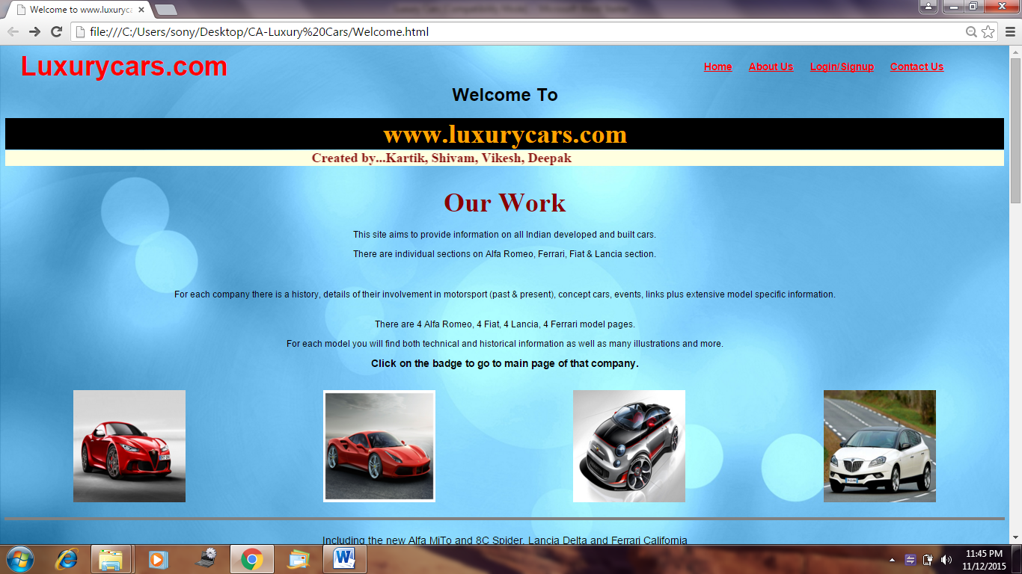

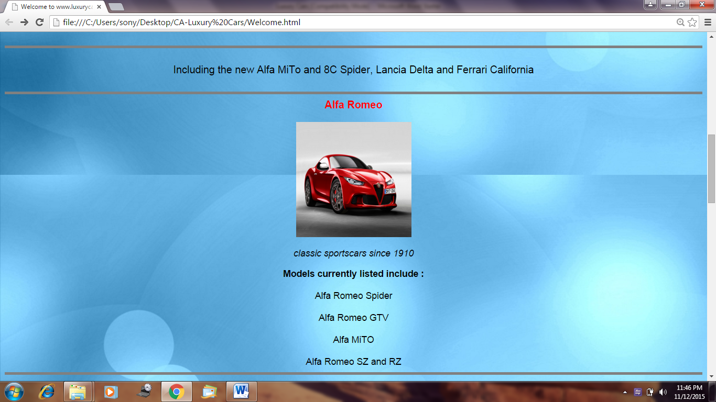

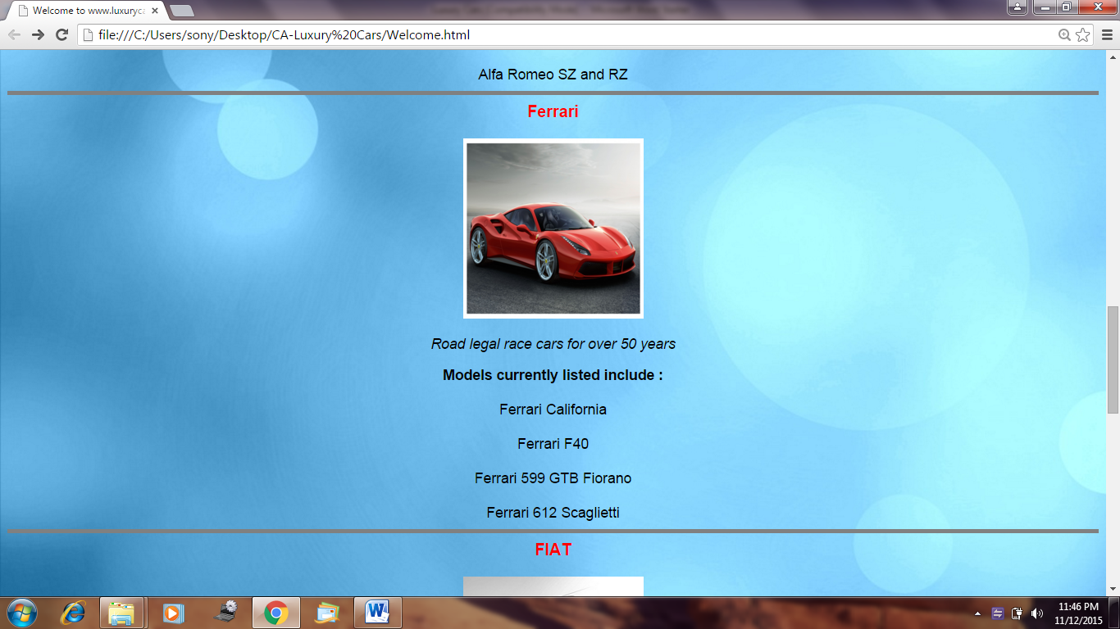

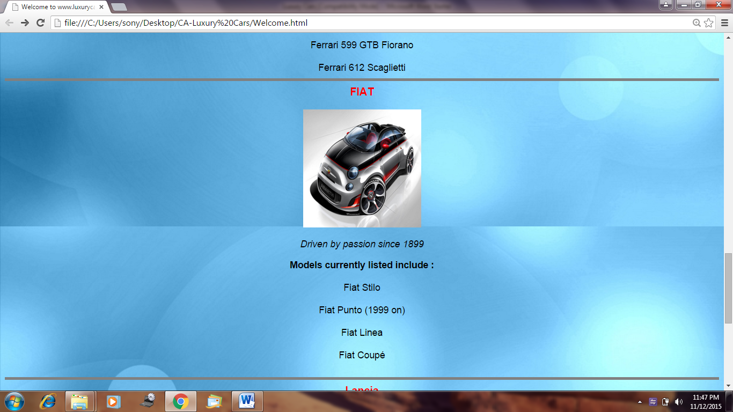

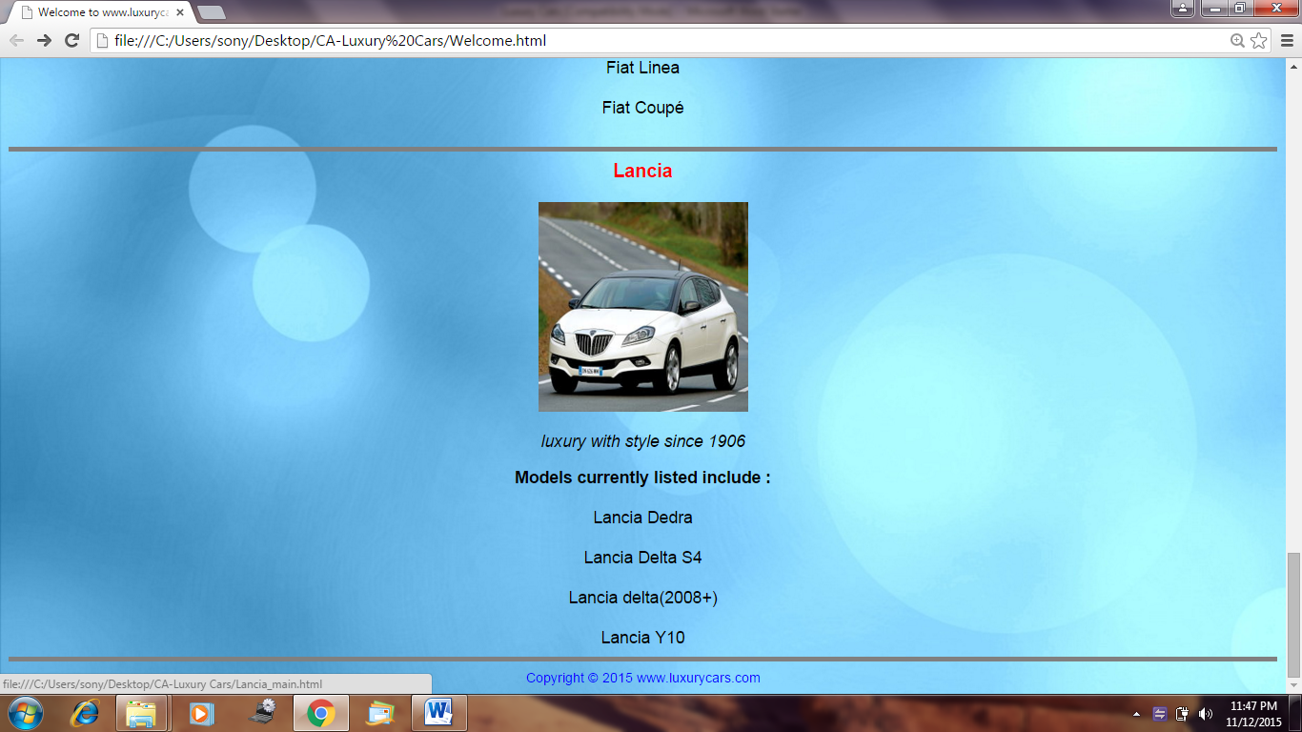

**1.1. Alpha Romeo**

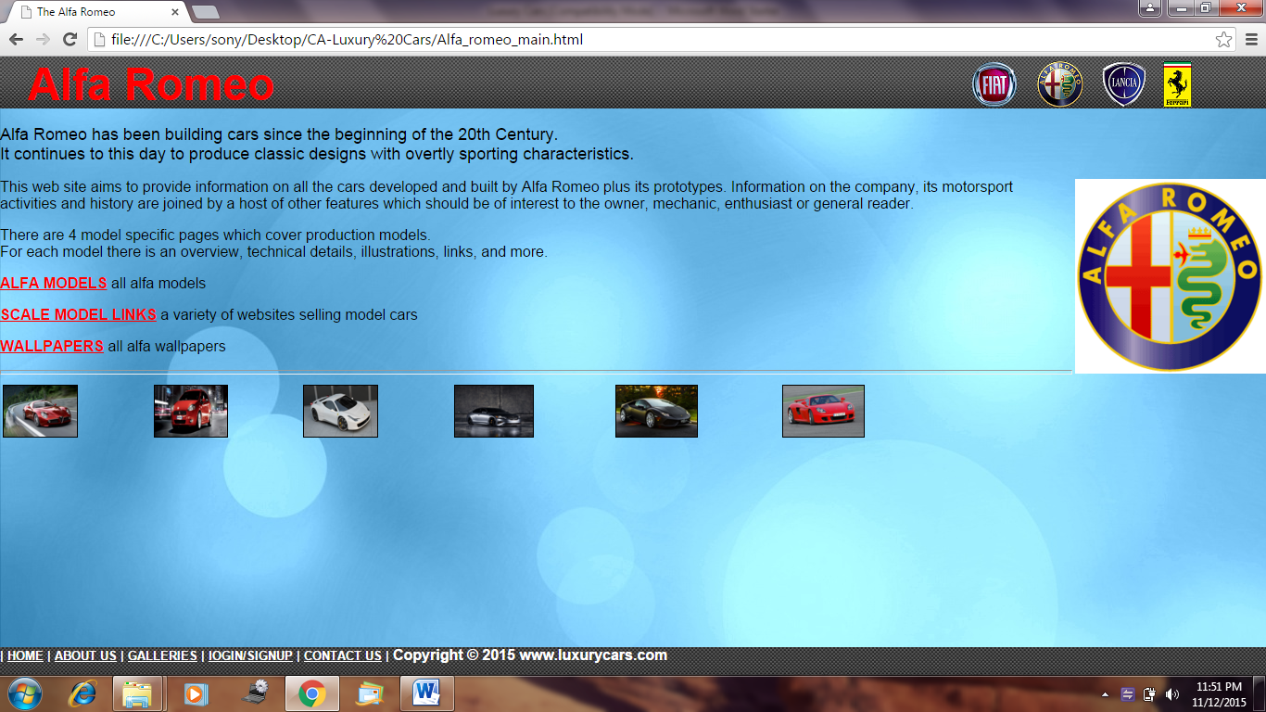

**1.2. Ferrari**

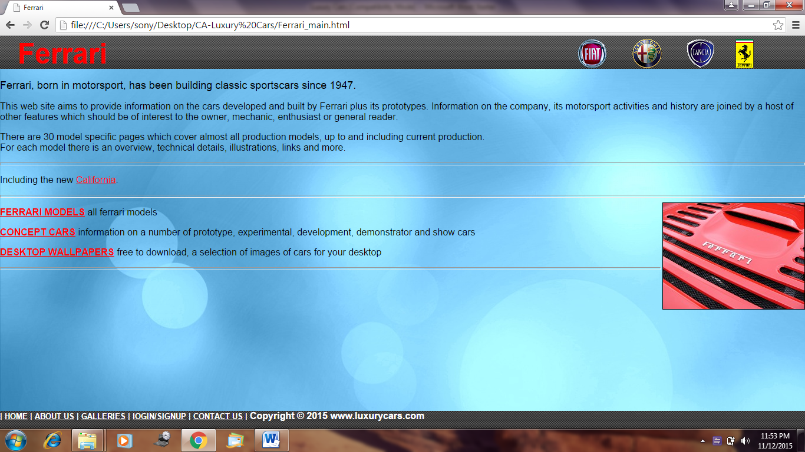

**1.3. Fiat**

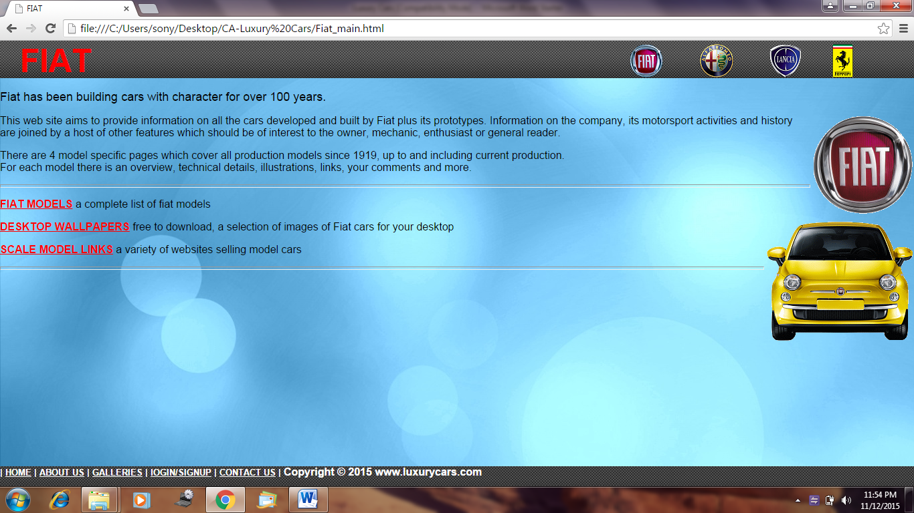

**1.4. Lancia**

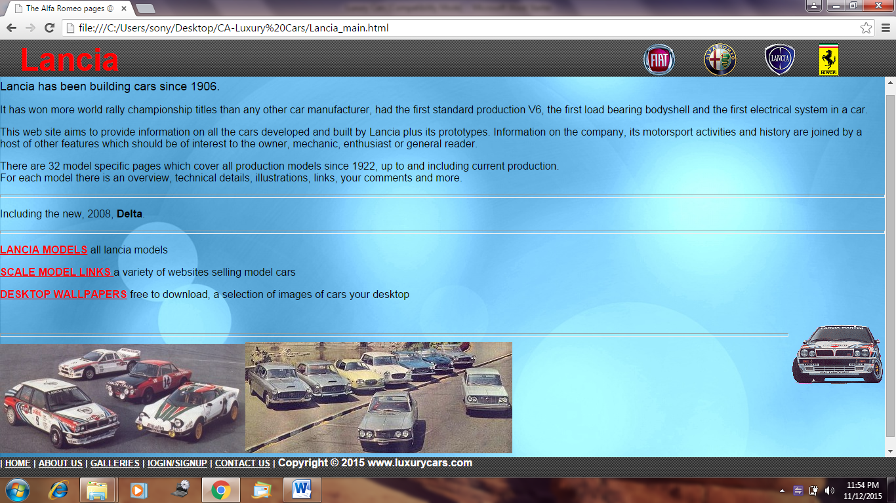

**1.5. Wallpapers**

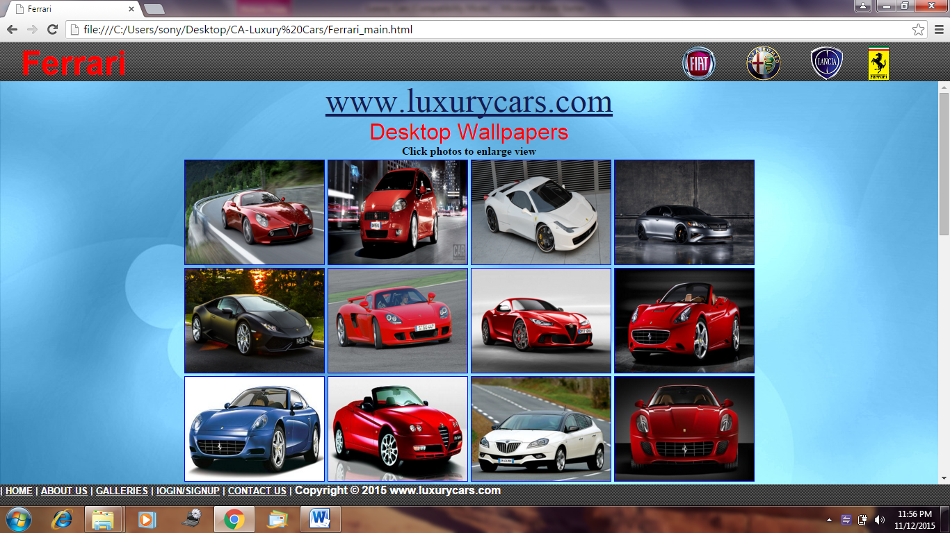

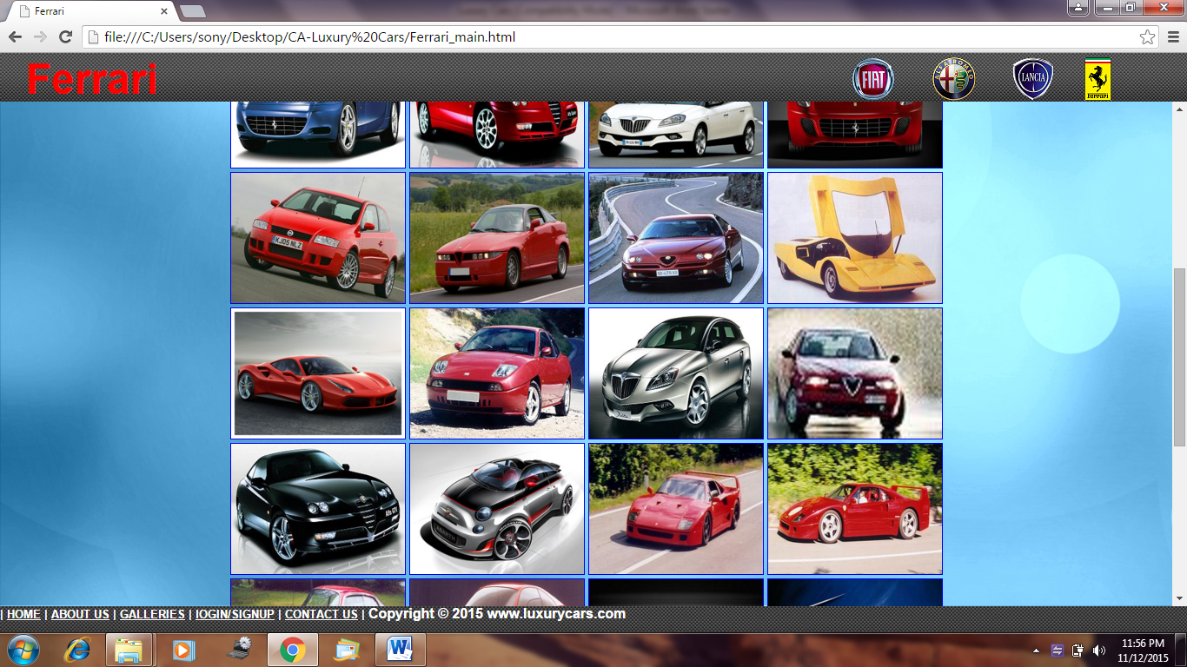

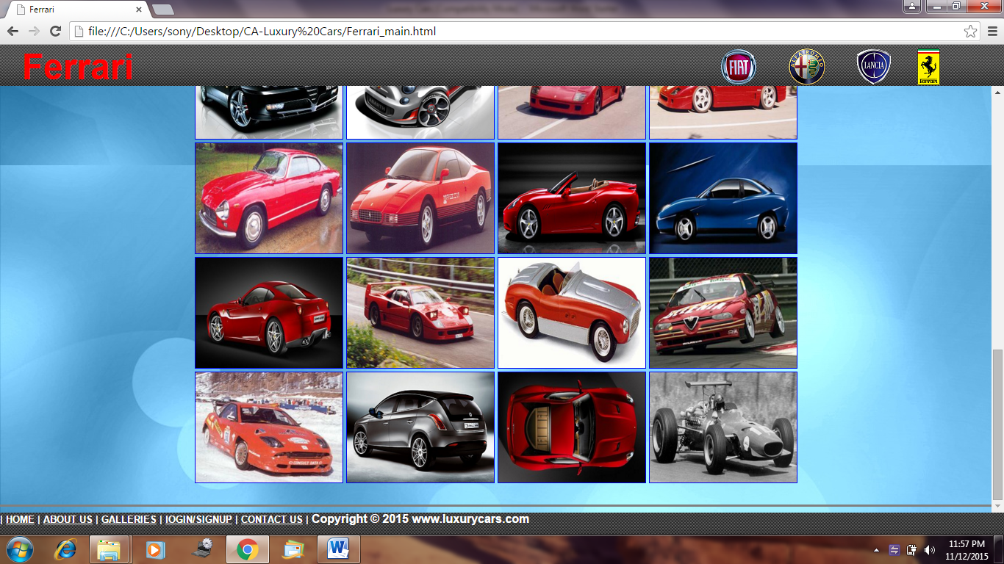

**2. About Us**

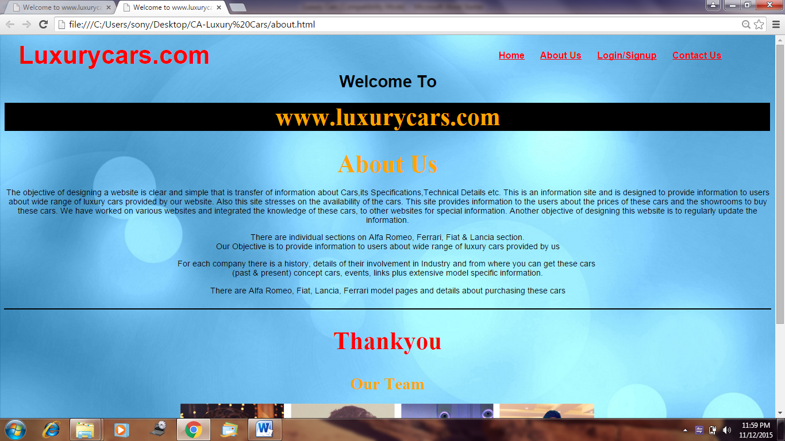

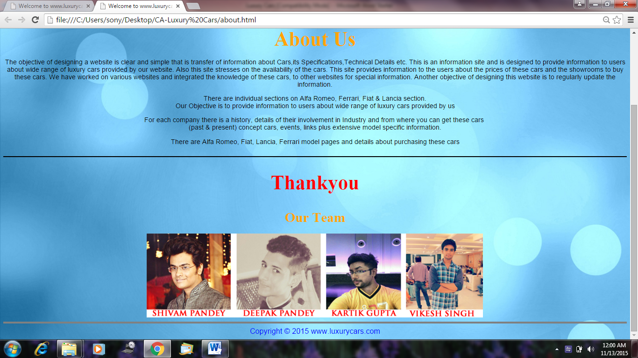

**3. Sign Up**

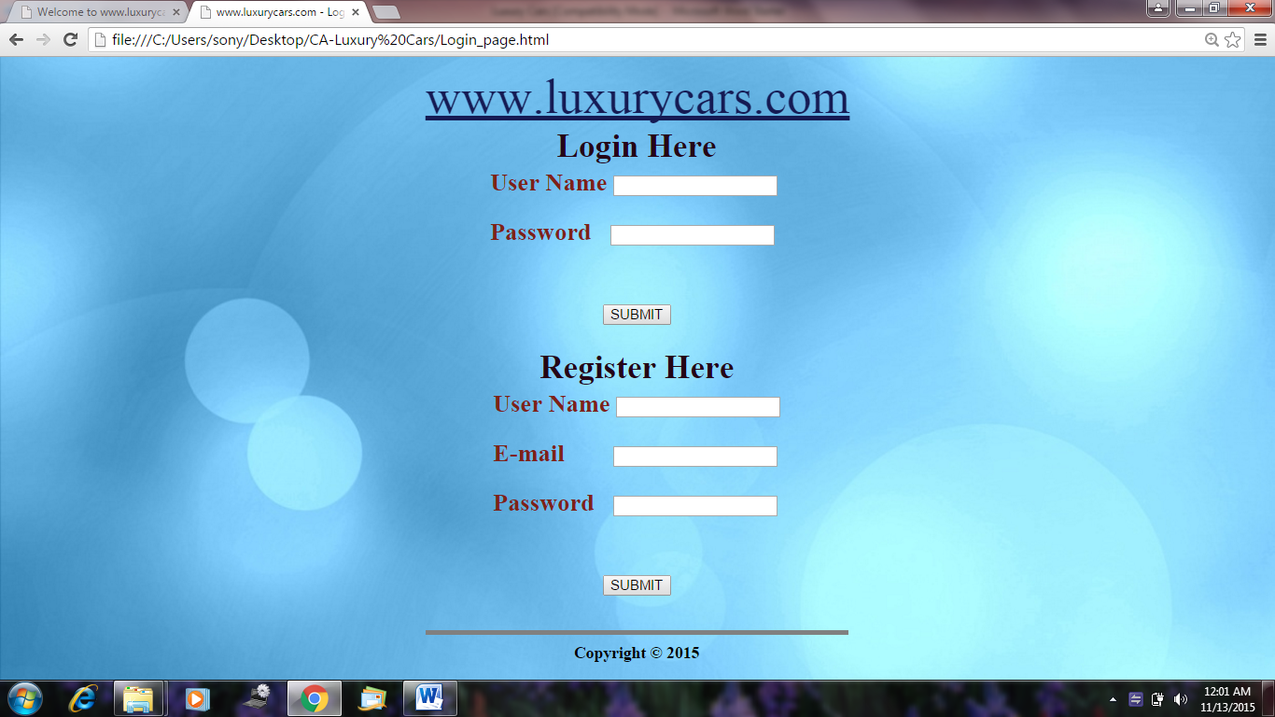

**4. Contact Us**

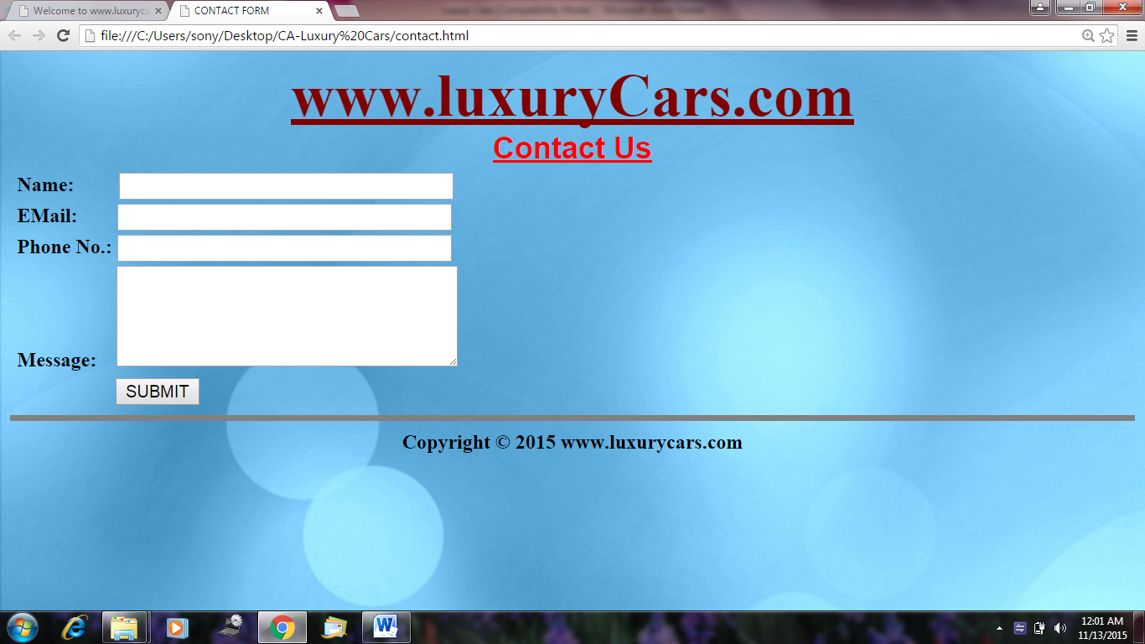

**5. Thank You**

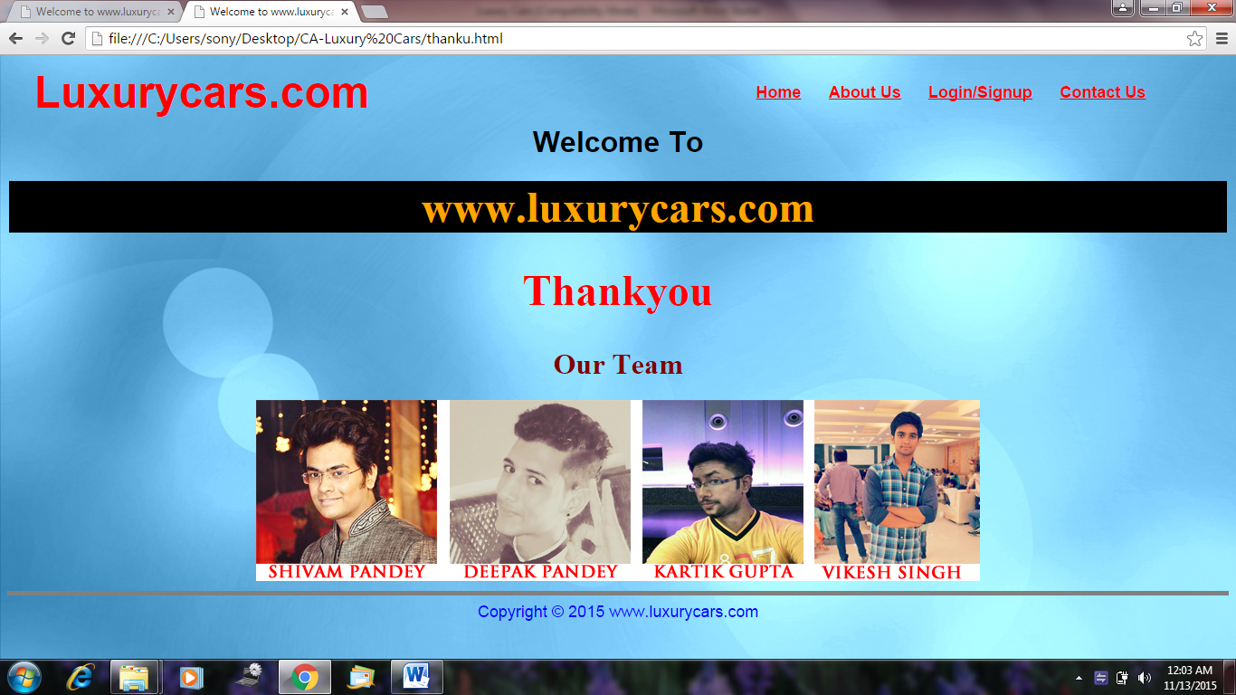

**Chapter–7**

**FUTURE**

**SCOPE**

**Future Scope**

There is a lot of scope in the field of informative websites of Luxury Cars as the information is 100% correct and genuine. The website will be updated minimum thrice in week and this helps the viewers to get a perfect review of a particular car more easily as the site would be user friendly and there is an option of signing up which helps the viewers to get notified and return to watch what’s new inside.

This will in future eliminate the need of searching here and there in the brochures, pamphlets or newspapers, etc to get to know latest about the luxury cars. There is a rise in the field of e-commerce and would also help in saving the time and fuel of the customer which would automatically save the money of customers.

This is the first step taken by us to change the living and searching pattern of viewers and this would surely emerge in our country and there would be a rise in the standard of living of the people of our country.

In terms of future scope, a variety of data mining techniques can be used by researchers to simplify viewer’s perceptions and attitudes. Every day, every hour and every minute, tera-bytes of data gets generated from millions of thousands of car companies, yet, retail managers/ business executives always grapple with relevant information that can help retailers/ researchers design strategies to generate viewer's loyalty. Some of the world’s largest companies such as BMW, AUDI, and MERCEDES, etc. utilize this data to generate certain knowledge that can help them in modelling and predicting viewer’s ad customer’s behaviour and further in order to know their reviews better. Thus data mining can not only be applied in retailing but also can be applied in the other sectors such as networking, banking, medicine, education, and tourism, insurance and so on. Data mining is the task of finding useful information/ knowledge from huge volume of data. Data mining can be applied through a variety of other techniques such as concept description, cluster analysis, factor analysis, classification and prediction, association analysis, evolution analysis, outlier analysis and many other different tools such as Clementine, Weka, Statistics, SAS, MINITAB, etc. can be used for the application of various data mining techniques.

**Chapter–8**

**REFERENCES**

Our project named www.luxurycars.com has been prepared and finalised by the help of various books and internet websites namely –

* www.wikipedia.com
* www.cardekho.com
* www.w3schools.com
* www.coolcars.com
* www.nvartscouncil.com

The books which were used while preparing this project were

* Computer application-II - Anuradha Aggarwal
* Beginning HTML –Jon Duckett
* Learn to code HTML and CSS – Shay Howe
* Website development- Anuradha Aggarwal